**Customer Segmentation / Clustering**

This report summarizes the results of customer segmentation using the **K-Means clustering algorithm**. The goal was to group customers into distinct clusters based on their profile and transaction behavior. The clustering was evaluated using the **Davies-Bouldin Index (DB Index)** and other relevant metrics.

**Plots to Find Optimal value of K**

1. Elbow method:

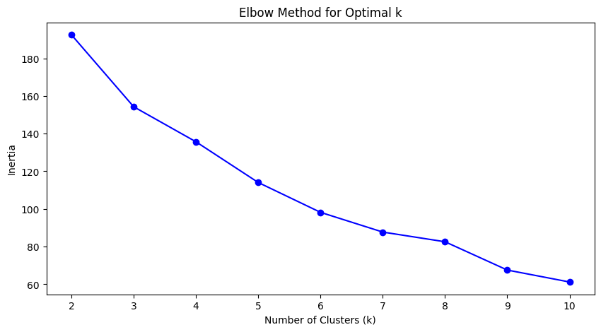

* Looking at the plot 4 and 5 looks more optimal for the k value.

1. Silhouette Score:

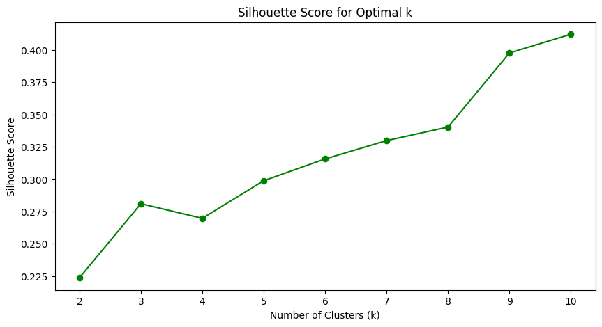

* Looking at the plot 10 looks more optimal for the k value as its approaching 1 and its closer towards 1 compared to other lower cluster values.

1. Silhouette Score:

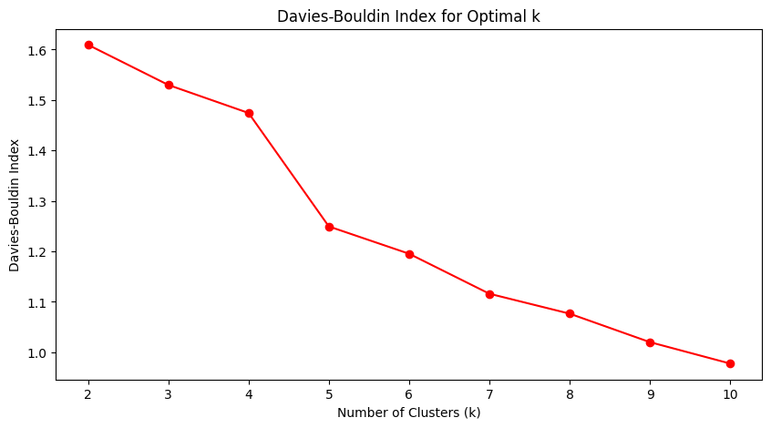

* Looking at the plot 10 looks more optimal for the k value.

**Tabular values:**

|  |  |  |
| --- | --- | --- |
| Clusters (K value) | Silhouette Score | Davies-Bouldin Index |
| 2 | 0.2237 | 1.6095 |
| 3 | 0.2810 | 1.5300 |
| 4 | 0.2696 | 1.4744 |
| 5 | 0.2988 | 1.2495 |
| 6 | 0.3156 | 1.1954 |
| 7 | 0.3298 | 1.1161 |
| 8 | 0.3402 | 1.0766 |
| 9 | 0.3976 | 1.0202 |
| 10 | 0.4121 | 0.9777 |

Based on the Tabular values k = 10 is more optimal compared to other lower cluster levels as the Silhouette is score is approaching 1 and Davies-Bouldin Index is lower compared to other values.

**Visualize clusters using PCA (2D):**

